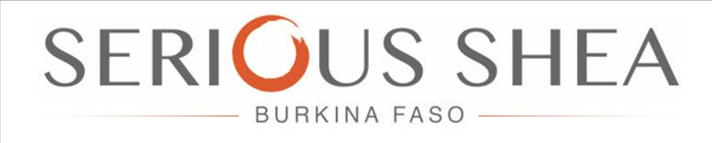

Serious Shea SARL
Ouagadougou
Secteur 29, 01 BP 6433
Ouagadougou 01 – Lot: 24
Section: XT Parcelle: 03
Burkina Faso

4th April 2019

Dear Sir/Madam,
Sustainable Shea Butter from Burkina Faso: Offer Letter
Serious Shea is a leading shea butter producer in Burkina Faso, part-owned by local women’s producers, and supported by the AfDB and World Bank. We expect to produce over 1,000mt of sustainable unrefined shea butter for export from Burkina Faso in 2020.
We are therefore welcoming letters of interests for the following products:
- Up to 3,750 metric tonnes of dried high-quality shea kernel. Available from Q1 2020.
- Up to 1,000 metric tonnes of high-quality shea butter with the following specifications:
  - Moisture: < 0.1%
  - Free fatty acid: < 1.5%
  - Insoluble impurities: < 0.01%l
  - Colour (51/4” Cell): < 5
  - Peroxide value: < 1Meq/kg
  - Iodine value 50 – 75gl2/100g
Our products have the following advantage:
- Product produced using renewable energy, zero-carbon processing methods, and completely avoiding deforestation
- Demonstrated social impact and fair-price provided to women’s groups (participating women’s groups also receive a significant profit share from the business)
- Full traceability of all products
- We will also be selling organic shea-butter following completion of the certification process
We expect to increase production as follows through expansion:
2020 | 2021 | 2022 | 2023
Shea kernels: 3,750t  Shea butter: 1,000t | Shea kernels: 5,000t  Shea butter: 2,000t | Shea kernels: 10,000t  Shea butter: 3,000t | Shea kernels: 20,000t  Shea butter: 5,000t

Buyers that indicate interest in the products at this stage will be considered preferential buyers. We look forward to hearing from you regarding your interest and requirements.
Yours sincerely,

William Kwende
Director, Serious Shea SARL

